**Steps to set up and create an app in React js**

1. **Install node js from any browser**
2. **After installing node js open command prompt and check the version of node and npm**
3. **Enter the command “node -v” for node version and “npm -v” for npm version**

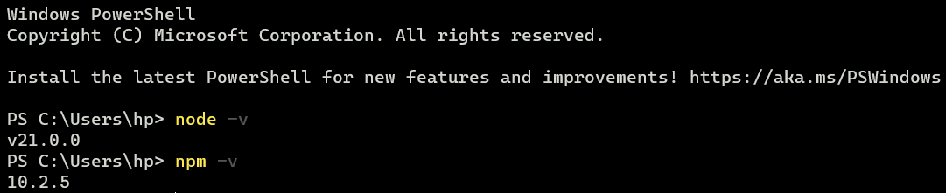

1. **Now install expo-cli package to create app and open that in expo go mobile app to download enter the command “npm install expo-cli --global” and press enter**



1. **After the download is completed it will display a message shown in the pic below**



1. **If this command doesn’t worked use the other command “npm install –global expo-cli”**
2. **Now change the directory by using the cd command and enter the path you want to create the project**



1. **Now create a new project named “ incredible to do app” by using the command “create-expo-app Incredible_Todo_App” and press enter**

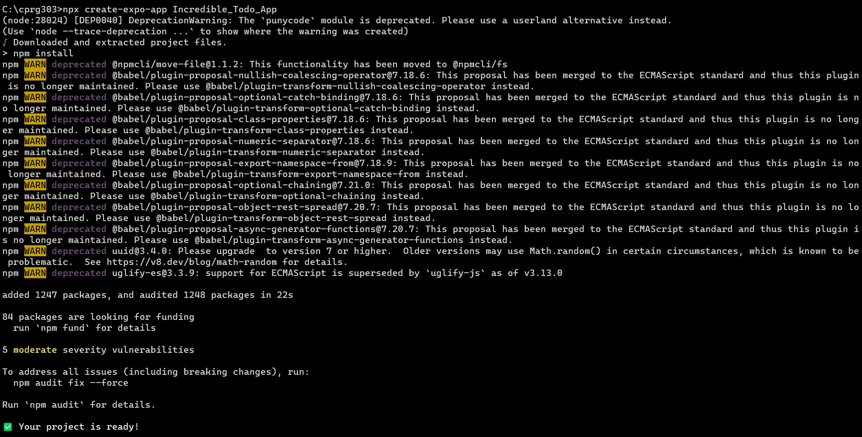

1. **Now to run the project first change the directory again by selecting the new project file and copy it path from files and enter it with the cd command as done before**

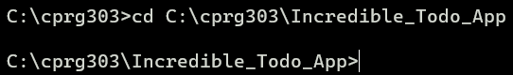

1. **Now enter the command “npm start “ to run the project**

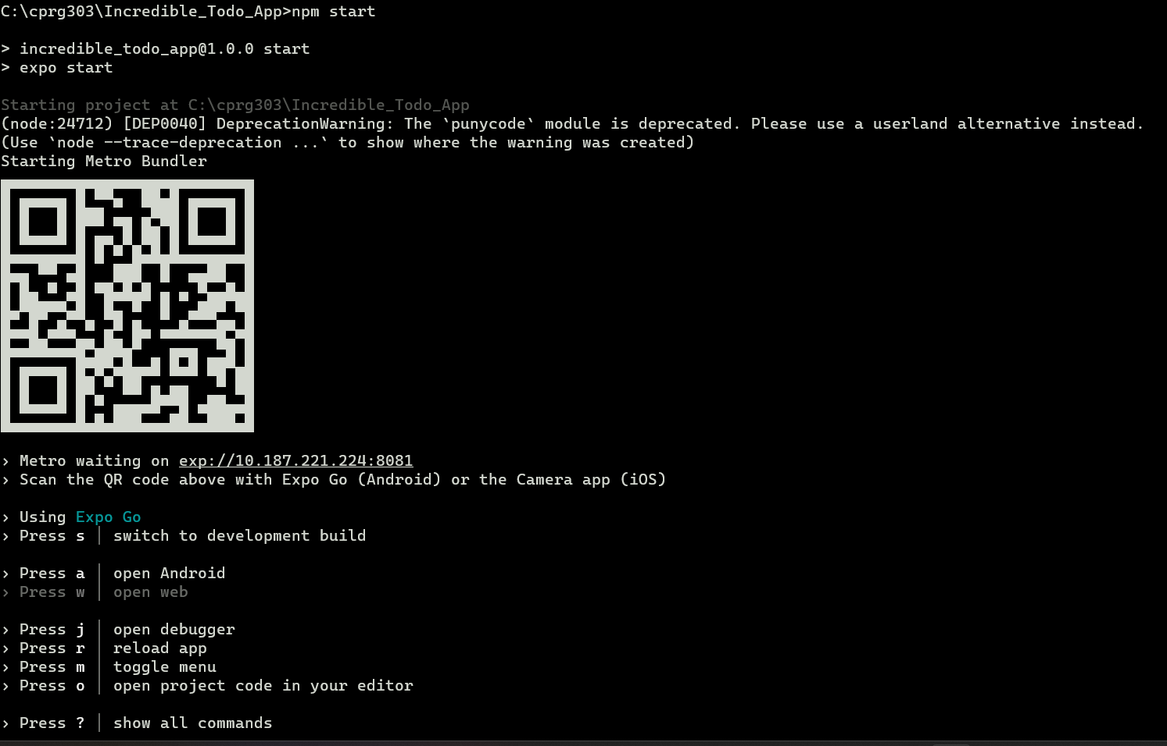

1. **You will see a qr code after running the start command**
2. **Now scan the QR code from your phone using the camera and you will be redirected to expo go app. Now you can edit the app in vs code and you will see the results in you phone**